Web Application Penetration Testing and Incident Response on DVWA
1. Executive Summary
This capstone project presents a comprehensive penetration test and incident response simulation conducted on the Damn Vulnerable Web Application (DVWA) in a controlled lab environment. The objective of the assessment was to identify common web application vulnerabilities, exploit them using industry-standard tools and techniques, and simulate an incident response process based on detected malicious activity.
Multiple critical vulnerabilities, including SQL Injection, Command Injection, Cross-Site Scripting (XSS), and weak authentication mechanisms, were successfully exploited. Apache web server logs were analyzed to detect indicators of compromise, followed by containment, eradication, and recovery actions. This project demonstrates practical skills in ethical hacking, log analysis, and incident response.
2. Introduction
Web applications are frequent targets of cyberattacks due to improper input validation, insecure authentication, and misconfigurations. DVWA is an intentionally vulnerable web application designed for security testing and learning purposes.
The purpose of this project is to simulate a real-world web application security assessment, followed by an incident response process, using DVWA as the target system in a legal lab environment.
3. Scope and Methodology
3.1 Scope
In Scope:
- DVWA web application
- SQL Injection
- Command Injection
- Cross-Site Scripting (XSS)
- Brute Force authentication attacks
- Apache log analysis
Out of Scope:
- Denial-of-Service (DoS) attacks
- Attacks against the underlying operating system
- External or production systems
3.2 Methodology
The assessment followed a structured approach:
- Environment setup
- Reconnaissance
- Vulnerability exploitation
- Incident detection via log analysis
- Incident response simulation
- Mitigation and recommendations
4. Environment Setup
- Operating System: Kali Linux
- Web Server: Apache2
- Database: MySQL / MariaDB
- Target Application: Damn Vulnerable Web Application (DVWA)
- Security Level: LOW
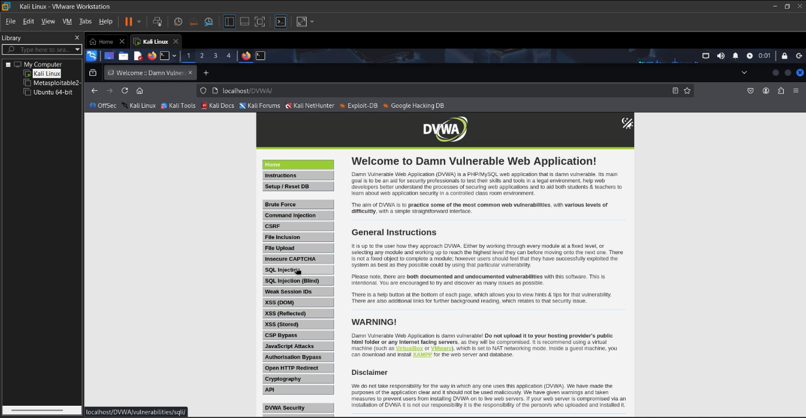
5. Reconnaissance
Network reconnaissance was conducted to identify open ports and services running on the target system.
Command Used
nmap -sV -p 80 127.0.0.1
The scan confirmed that the Apache web server was running on port 80, indicating a web application attack surface.
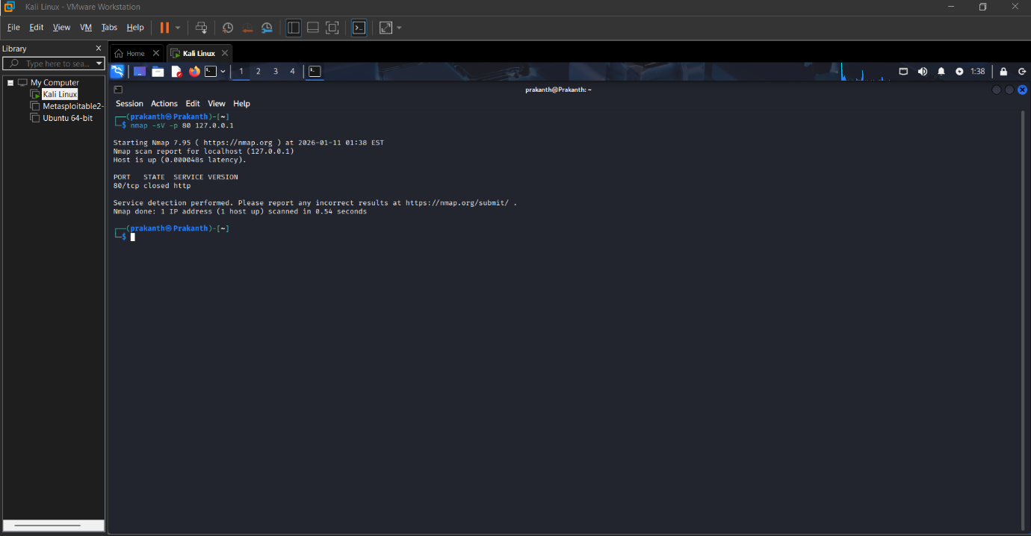
6. Vulnerability Assessment and Exploitation
6.1 SQL Injection
Description:
SQL Injection allows attackers to manipulate database queries by injecting malicious SQL statements through user input fields.
Payload Used:
' OR '1'='1 --
Impact:
- Authentication bypass
- Unauthorized access to user data
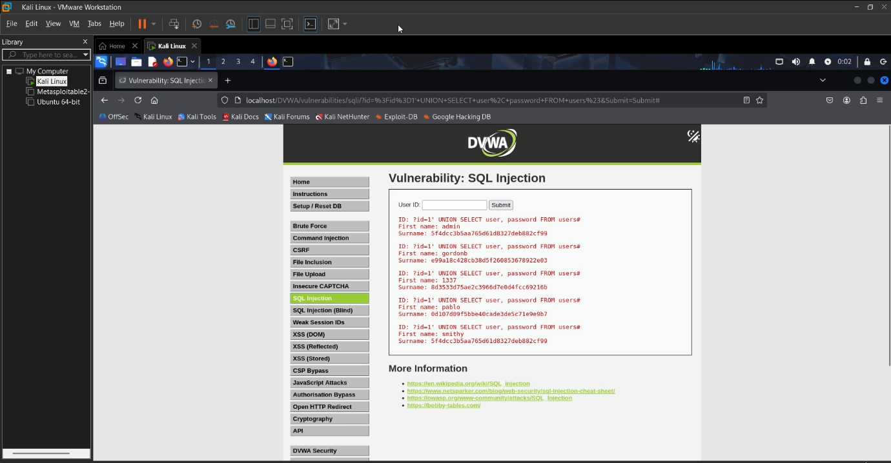
6.2 Command Injection
Description:
Command Injection occurs when user input is executed as a system command by the server.
Payload Used:
127.0.0.1; whoami
Impact:
- Execution of arbitrary system commands
- Potential full system compromise
6.3 Cross-Site Scripting (XSS)
Description:
XSS allows attackers to execute malicious JavaScript in a victim’s browser.
Payload Used:
<script>alert('XSS')</script>
Impact:
- Session hijacking
- Credential theft
- Client-side attacks
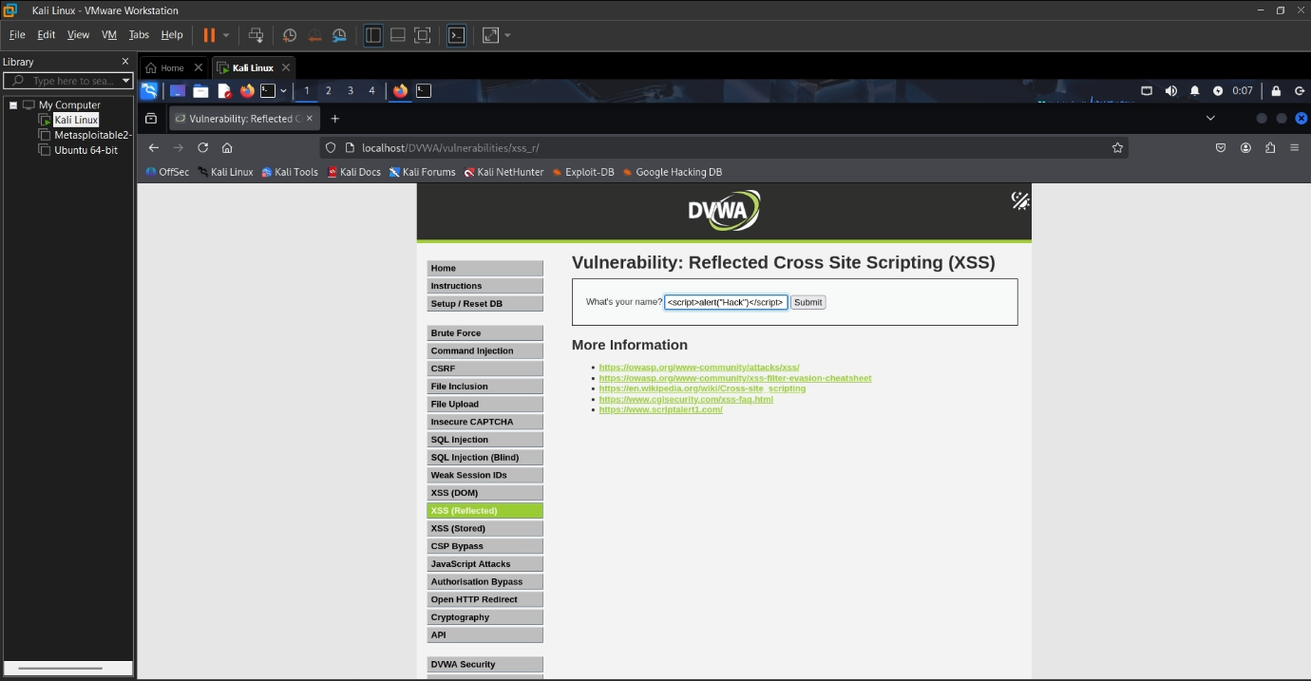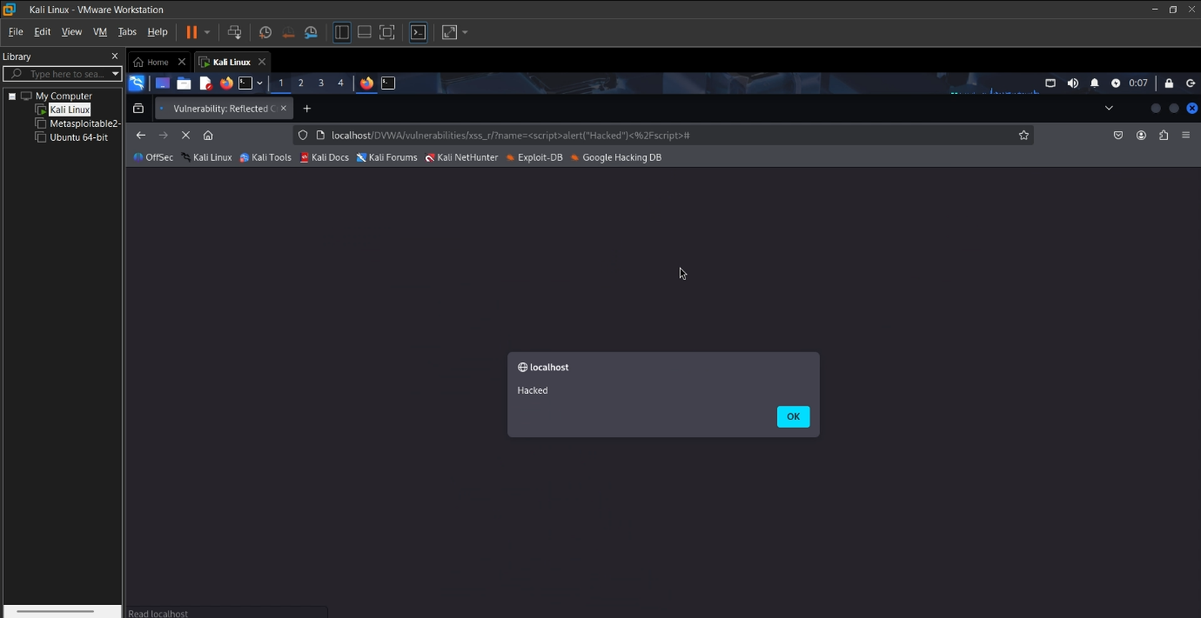
6.4 Brute Force Attack
Description:
A brute force attack was conducted against the DVWA login page using a password Tool Used: Hydra
Impact:
- Weak credentials compromise
- Unauthorized access
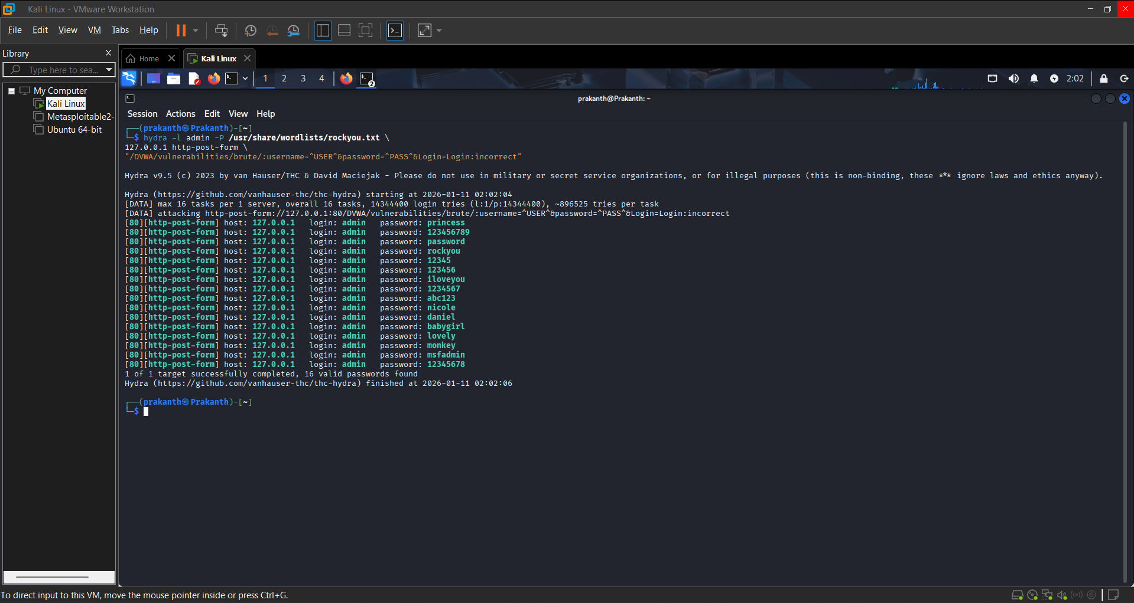
7. Incident Detection and Log Analysis
Following exploitation, Apache access logs were analyzed to detect malicious activity.
Log File Reviewed
/var/log/apache2/access.log
Indicators of Compromise Identified
- SQL Injection payload: 'OR 1=1'
- Command Injection payload: whoami
- XSS payload: <script>
Detection Command
sudo grep -Ei "script|whoami|or.*1=1" /var/log/apache2/access.log
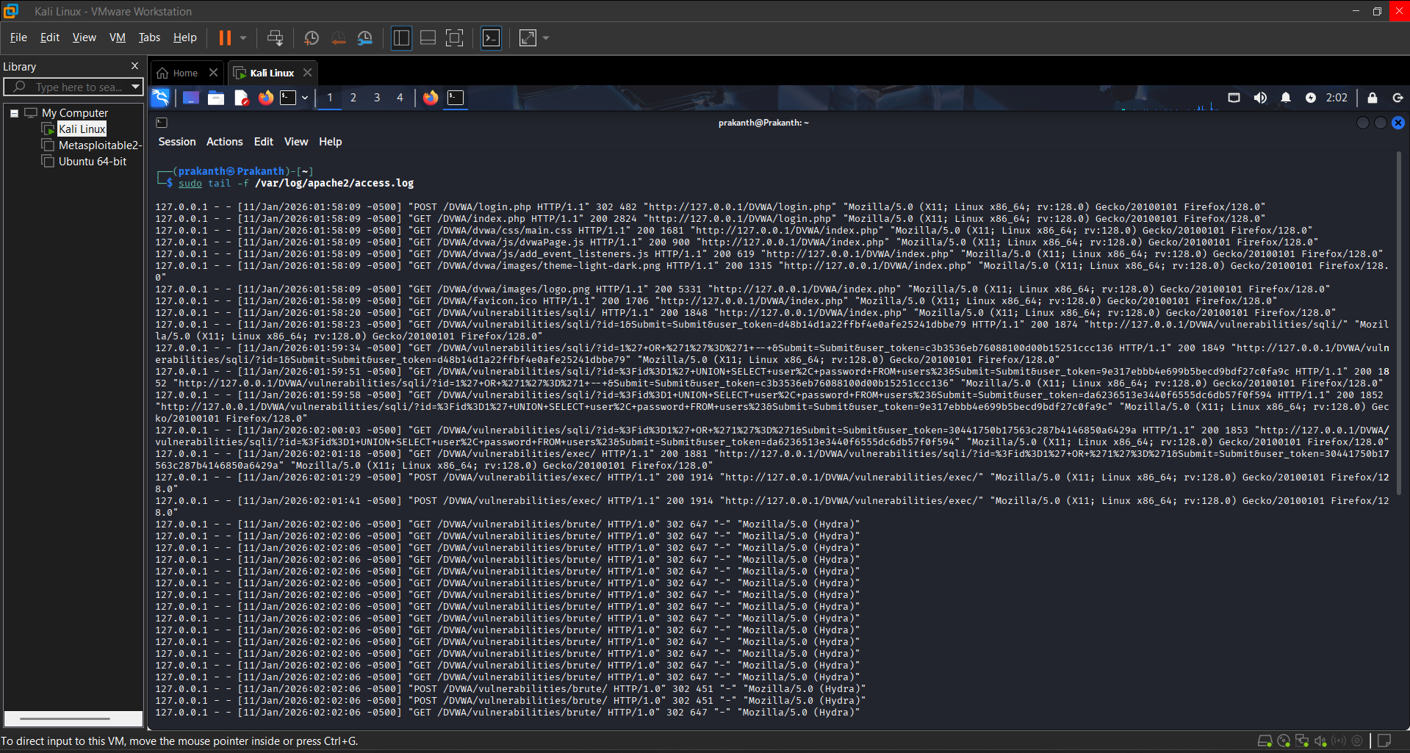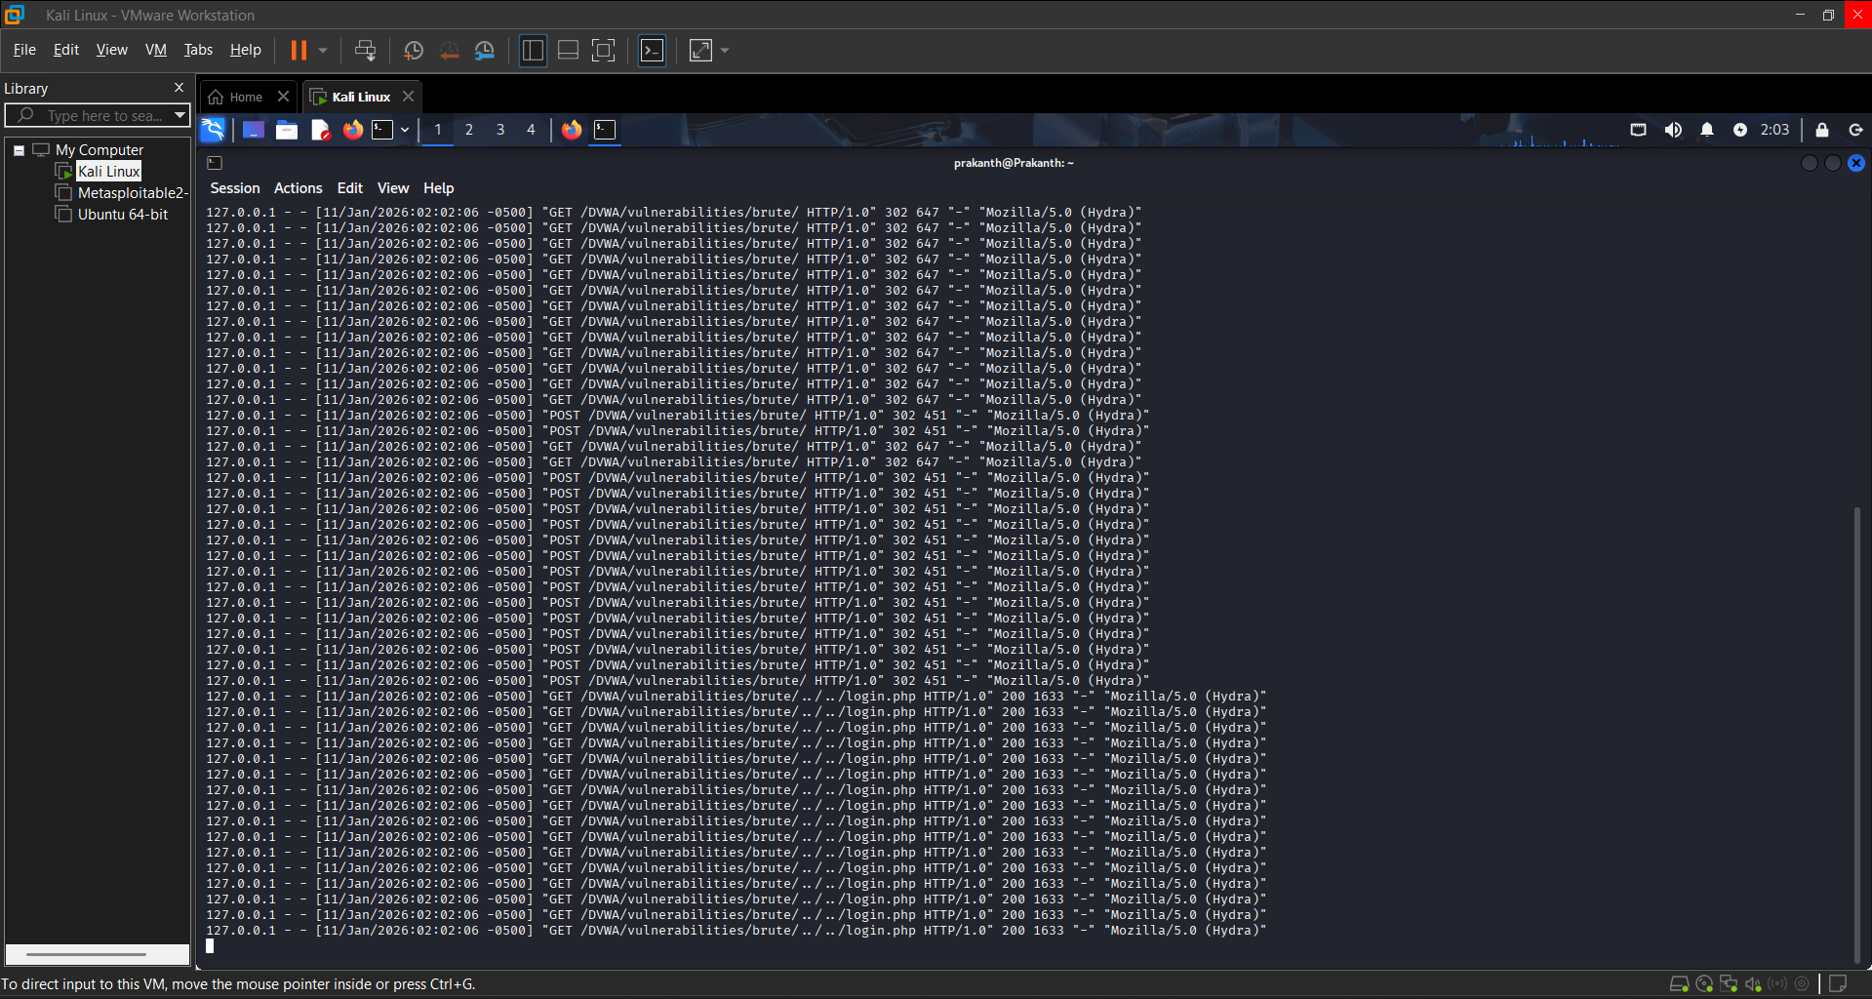
8. Incident Response Simulation
8.1 Detection
Suspicious HTTP requests containing known attack payloads were identified in Apache logs.
8.2 Containment
The attacker IP address was blocked using firewall rules to prevent further malicious requests.
sudo iptables -A INPUT -s 127.0.0.1 -j DROP
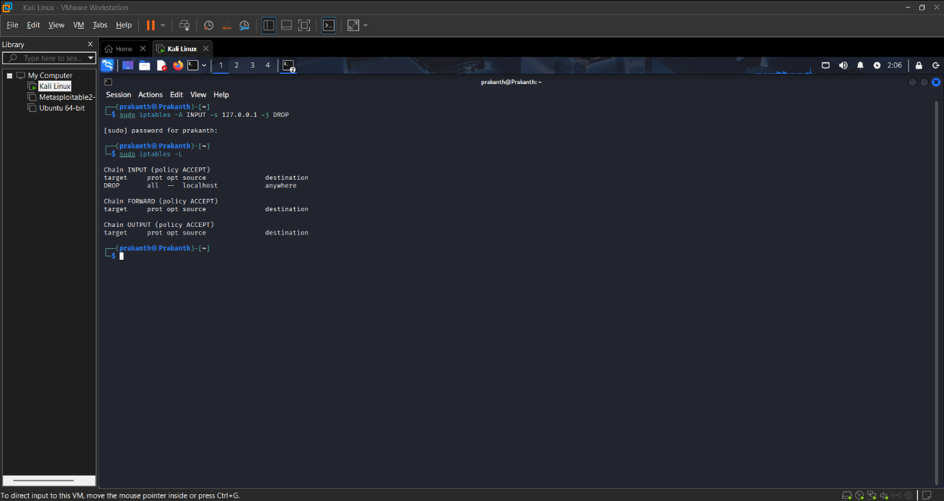
8.3 Eradication
- DVWA security level was increased from LOW to MEDIUM/HIGH
- Vulnerable configurations were disabled
- Apache service was restarted
sudo systemctl restart apache2
8.4 Recovery
The web application was verified for normal operation and logs were continuously monitored for suspicious activity.
curl http://127.0.0.1/DVWA
9. Mitigation and Recommendations
Vulnerability | Recommended Mitigation
SQL Injection | Use prepared statements and parameterized queries
Command Injection | Input validation and command whitelisting
XSS | Output encoding and input sanitization
Brute Force | Account lockout and rate limiting
Logging | Centralized logging and real-time monitoring

10. Conclusion
This capstone project successfully demonstrated the process of identifying, exploiting, detecting, and mitigating common web application vulnerabilities. By combining penetration testing with incident response techniques, the project highlights the importance of proactive security testing and effective monitoring. The skills demonstrated in this assessment are directly applicable to real-world cybersecurity and SOC operations.
11. References
- OWASP Top 10
- DVWA Official Documentation
- Apache Logging Documentation
- Kali Linux Tool Documentation
12. ER Diagram
